 | Assignment No. 2  Semester: Fall 2024  CS310 – Open Source Web Development | Total Marks: 20  Due Date: 30/12/2024

Instructions
Please read the following instructions carefully before submitting the assignment solution:
It should be clear that your assignment will not get any credit/marks if:
- Assignment is submitted after due date.
- Submitted assignment does not open or file is corrupt.
- Assignment is copied (From internet/students).

Objectives

- Understanding Form Validation
- Implementing Input Sanitization
- Error Handling and Feedback
- Practical Application of PHP Forms

Assignment Submission Instructions
You have to submit only “.php” file of your code on the assignments interface from your LMS account.
Assignment submitted in any other format will not be accepted and will be scaled with zero marks. No excuse will be accepted on submitting solution file in any other format.
For any query related to assignment, please contact cs310@vu.edu.pk.

Problem Statement:
You are required to create a feedback form for an event. The form collects the following details from participants:
- Name
- Email Address
- Event Rating (1 to 5)
- Comments
Your assignment involves the following tasks:
- Input Validation:
Validate all form inputs to ensure they meet the following requirements:
  - Name: Should not be empty and must contain only letters and spaces.
  - Email Address: Should be in a valid email format.
  - Event Rating: Should be a number between 1 and 5.
  - Comments: Should not exceed 250 characters.
- Input Sanitization:
Sanitize all inputs to remove unnecessary spaces and special characters.
- Error Handling:
Display appropriate error messages for invalid inputs next to the respective fields.
- Confirmation Message:
If all inputs are valid, display a confirmation message with the sanitized data.

Sample Input and Validation Criteria:
Input Field | Criteria | Example
Name | Only letters and spaces, not empty | John Doe
Email Address | Valid email format | john.doe@example.com
Event Rating | Number between 1 and 5 | 4
Comments | Maximum 250 characters | "Great event! Loved it."

Sample Output:

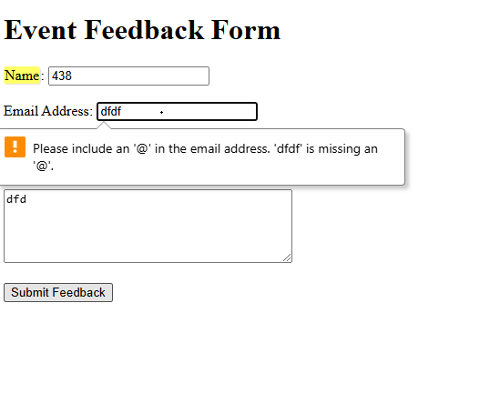

Weeks Covered: 7 - 10
Due Date: Monday, December 30, 2024.

